Open SAE J1939

Foreword
SAE J1939 is a protocol for shaping the CAN-bus message in a specific way that suits industrial vehicles such as tractors, machinery, trucks and more.

SAE J1939 is a very easy protocol to use, but there is a lack of information about SAE J1939, due to the cost of the protocol document, available how to shape a CAN-bus message according to SAE J1939 protocol standard. So therefore I’m writing a SAE J1939 protocol available for free to use on any embedded systems such as STM32, Arduino, AVR, PIC etc.

To learn to build on this project, you need first to understand SAE J1939. I have written this project in C language because C is an industry standard. The C language dialect I have chosen is ANSI C (C89) and I don’t use dynamical memory allocation in this library. So it will work with MISRA C standard.

With this library, you can communicate with valves, engines, actuators, hardware and all other things that are suitable for heavy industrial mobile applications. I have build up a basic structure of the project and I hope that other users will send pull request of their C code for extra functionality to SAE J1939 standard because SAE J1939 is a huge standard.

- Daniel Mårtensson, Sweden, 2021-07-14

Table of Contents
Foreword 1
Quick introduction to SAE J1939 ID and DATA 2
Functionality overview of Open SAE J1939 3
Open SAE J1939 4
Listen For Messages 4
SAE J1939:71 Application Layer 4
Request Software ID 4
Request Component ID 4
Request ECU ID 4
Request Vehicle Identification Number (VIN) 4
Request Proprietary A 4
Request Proprietary B 4
ISO 11783-7 Application Layer 4
SAE J1939:73 Diagnostics Layer 5
SAE J1939:81 Network Layer 5
SAE J1939:21 Transport Layer 5
SAE J1939 Protocol 5
Request 5
Acknowledgement 6
Transport Protocol Connection Management RTS/BAM 7
Transport Protocol Connection Management CTS 8
Transport Protocol Connection Management EOM 9
Transport Protocol Connection Management Abort 10
Transport Protocol Data Transfer 12
Address Claimed 12
Address not claimed 13
Commanded Address 14
Delete Address 15
DM1 15
DM2 17
DM3 18
DM11 – Not supported 18
Proprietary A 18
Proprietary B PGNs 19
Software identification 19
ECU identification 20
Component identification 21
DM14 & DM15 and DM16 22
ISO 11783 Protocol 24
ISO 11783-7 Application Layer 24
Auxiliary Valve Command 24
General Purpose Valve Command 25
Auxiliary Valve Estimated Flow 26
General Purpose Valve Estimated Flow 27
Auxiliary Valve Measured Position 28
Revision 29

Quick introduction to SAE J1939 ID and DATA
First you need to understand the data frame of SAE J1939. The data frame of SAE J1939 is basically one ID and one DATA. ID and DATA is the information we are going to send through the CAN-bus network.
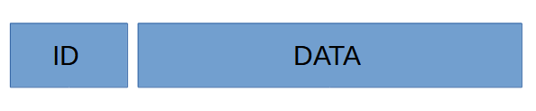Figure 1: SAE J1939 Data frame

ID contains 4 hex values and DATA contains maximum 8 hex values e.g 8 bytes values.
An ID can be shaped as this 0x18FE8022 where 80 is the destination address, called DA and 22 is the source address, called SA. So you more likely going to see ID numbers as this 0x18FE’DA’’SA’

The DA address and SA address is the addresses of the ECU – Electronic Control Unit, e.g microcontroller/PCB board. You self decide what address your ECU should have. For example. If you have two ECU that are going to communicate to each other. Then you have for example ECU1 address as 0xA1 and ECU2 as 0xA5. If ECU1 want to send a message to ECU2, then the destination address DA would be 0xA5 and the source address SA would be 0xA1. If ECU2 want to send a message to ECU1, then DA would be 0xA1 and source address SA would be 0xA5.

So keep that in mind that when I’m talking about SA and DA, it’s only about source address and destination address of the ECU. When it comes to the rest of the ID values 0x18FE, they are just there to describe the type of message. Each message have a unique ID and therefore the ID will be shaped differently. Sometimes, DA in the ID message is replaced by a unique hex value.

The length of DA and SA are from 0x0 to 0xFD because 0xFE is error address and 0xFF is broadcast address.

DATA is just 8 bytes of data. DATA holds information about anything the user want to send to other ECU. Sometimes DATA can be 3 bytes depending on if we are sending a unique message.

Functionality overview of Open SAE J1939
Open SAE J1939 is just basic C-code, arrays, function, structures and bitwise operations. Nothing more. I have shaped this project according to this map below. This map describe basic overview of the project. Some functions may have been added after this document was made, but the structure is the same. Those functions are inside the green box and they are called extra functionality of the project.
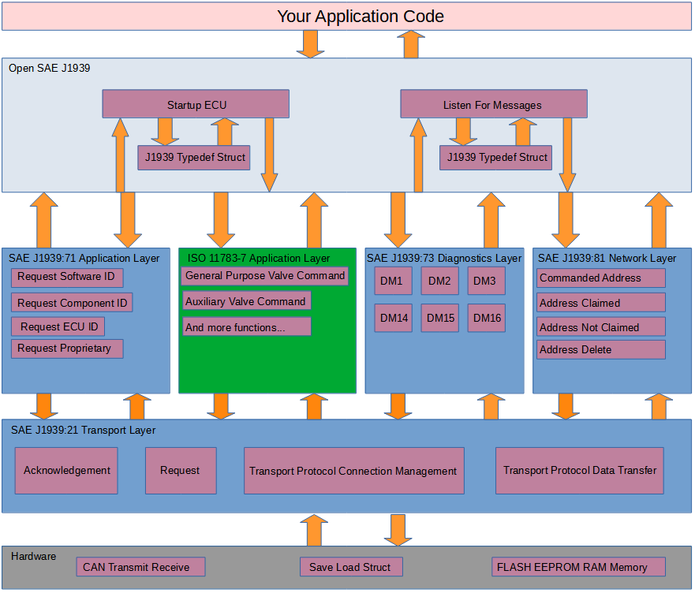Figure 2: Structure of this project
We begin from the top. The J1939 Typedef Struct. That structure is just a basic C code typedef struct that holds information about all ECU who are connected to the CAN-network. The struct can be found at the Open SAE J1939 folder.
The idea behind the struct:
- The struct holds source address of all ECU
- The user are going to create a C pointer of the struct and pass it to the SAE J1939 functions, like an object where the user pass that object as argument in the functions. So you can interpret that object as likely basic OOP in C.
- The struct hold temporary information about other ECU
- The struct hold information about their own ECU
- The struct holds the source address from where the message came from

Open SAE J1939

Listen For Messages
This function is called all the time by the user. Most likely inside a while loop. This function reading ID and DATA directly and split ID into 4 different ID for determine what kind of ID it is and what to do next. It split up ID, check what ID it is and then check what function it want to call and then pass that DATA + source address SA + pointer of the struct to that function as argument. That’s it. Listen For Messages is just a function who select which function we want to call, depending on how the ID looks like.

SAE J1939:71 Application Layer

Request Software ID
Every ECU has a software ID for example a number or a text that describe for example BIOS software or software version. Call this function if you want to request the software ID from other ECU. The ECU will then response back to you with information.

Request Component ID
Every ECU has a component it control. It can be for example a motor, valve or other thing. Call this function if you want the ECU to send information about the component that ECU controls.

Request ECU ID
Same as above. Call this function if you want to know the ID information about the ECU you are sending to.

Request Vehicle Identification Number (VIN)
Some ECUs contain “static” vehicle information such as the VIN, an identifier unique to every chassis containing the make, model, installed options and other information to identify the specific vehicle. Call this function if you want to retrieve the VIN from an ECU. The ECU will then response back with the 17 character VIN.

Request Proprietary A
Proprietary A is a holder for manufacturer specific data. When this, you can add your specific data if you want to broadcast or send to a unique ECU address.

Request Proprietary B
Proprietary B are a group of messages defined by the standard to hold manufacturer specific data. With this, you request specific manufacturer data to a specific ECU.

ISO 11783-7 Application Layer
Here I have selected the application layer of agriculture, tractors and machinery ISO standard. That application layer contains these functions:
- General Purpose Valve command – Sending control messages to ECU for controlling valves
- Auxiliary Valve Command – Sending control messages to ECU for controlling valves
- General Purpose Valve Estimated Flow – Get the computed flow from a valve
- Auxiliary Valve Estimated Flow – Get the computed flow from a valve
- Auxiliary Valve Estimated Position – Get the computed position of the valve main spool

SAE J1939:73 Diagnostics Layer
Diagnostics layer contains messages about errors, but it also can contains functionality such as memory access of the EEPROM (built in “hard drive”) or command for deleting error messages.
- DM1 – Contains error messages such as electrical fault, location etc
- DM2 – Contains previous active DM1 messages
- DM3 – Deleting DM2 messages
- DM14 – Memory request of bytes, address etc from a ECU
- DM15 – Memory response from a DM14 request from that ECU
- DM16 – Binary data transfer (if DM15 repose was OK)

SAE J1939:81 Network Layer
At the startup of an ECU, the ECU sending Address Claimed, which means it giving out the information about something called NAME. NAME is basic information about the ECU + SA.

- Address Claimed – Send out NAME + ID that holds SA.
- Address Not Claimed – Send out NAME + ID that holds Address Not Claimed.
- Commanded Address – Send this to an ECU and you can change its NAME and SA.
- Delete Address – Send a command to other ECU or all ECU for deleting a specific address. This is not SAE J1939 standard.

SAE J1939:21 Transport Layer
- Acknowledgement – Send a OK, BUSY, WAIT etc. as a response on a request.
- Request – Asking information or functionality about an ECU.
- Transport Protocol Connection Management – Send how much data in packages you want to send to the receiver.
- Transport Protocol Data Transfer – Send the data in packages to the receiver.

SAE J1939 Protocol

Request
Request are used when we want to ask an ECU of “something”. That “something” is a PGN number. Enter a PGN number, send the message and get a response from that ECU directly. All PGN numbers can be found in Enum_PGN.h
Message ID | 18 EA "DA" "SA"
PGN | 0x00EA00 (59904)
Peer to Peer/Broadcast | Peer to Peer or Broadcast with DA = 0xFF (Used for Address Claimed)
Message length | 3 bytes
Multipacket | No
Byte 1 | PGN LSB
Byte 2 | PGN
Byte 3 | PGN MSB

Field | Min value | Max value | Explanation | Enum
PGN | 0x0 | 0xFFFFFF | Request command | Enum_PGN.h

In case you did not understand what LSB and MSB is. LSB stands for least signifiant bit and MSB stands for most signifiant bit. LSB means the lowest number and MSB means the highest number. If we want to send the PGN number 0x18EEA1, then the LSB is 0xA1 because that’s the lowest number and MSB is 0x18 because that’s the highest number. The same reason when you write out 1024 where you begin with highest number 1(1000), then 0(000), then 2(20) and last 4. 1000 + 000 + 20 + 4 = 1024. So keep that in mind that MSB is the highest number and LSB is the lowest number.

Acknowledgement
Acknowledgement are used when we want to response back to an ECU e.g completed, busy, not available etc.
Message ID | 18 E8 "DA" "SA"
PGN | 0x00E800 (59392)
Peer to Peer/Broadcast | Peer to Peer
Message length | 8 bytes
Multipacket | No
Byte 1 | Control byte
Byte 2 | Group function value
Byte 3 | 0xFF (Reserved)
Byte 4 | 0xFF (Reserved)
Byte 5 | Address
Byte 6 | PGN of requested info LSB
Byte 7 | PGN of requested info
Byte 8 | PGN of requested info MSB

Field | Min value | Max value | Explanation | Enum
Control byte | 0x0 | 0xFF | Describes the status of the requested PGN | Enum_Control_Byte.h
Group function value | 0x0 | 0xFF | The function code that specify the cause of the control byte | Enum_Group_Function_Value.h
Address | 0x0 | 0xFF | The source address of the ECU from where the acknowledgement came from
PGN of requested info | 0x0 | 0xFFFFFF | The same PGN number in the request | Enum_PGN.h

Transport Protocol Connection Management RTS/BAM
This describe for the receiver ECU how many packages and total size of data the transmitter is going to transmit to the receiver via the Transport Protocol Data Transfer. RTS stands for Request To Send and BAM stands for Broadcast Announce Message.
Message ID | 1C EC "DA" "SA"
PGN | 0x00EC00 (60416)
Peer to Peer/Broadcast | Peer to Peer
Message length | 8 bytes
Multipacket | No
Byte 1 | Control byte
Byte 2 | Total message size being transmitted LSB
Byte 3 | Total message size being transmitted MSB
Byte 4 | Number of packages being transmitted
Byte 5 | Max number of packages in response to CTS
Byte 6 | PGN of the packeted message LSB
Byte 7 | PGN of the packeted message
Byte 8 | PGN of the packeted message MSB

Field | Min value | Max value | Explanation | Enum
Control byte | 0x0 | 0xFF | Describes how the data transfer should become | Enum_Control_Byte.h
Total message size being transmitted | 0x9 | 0x6F9 | Total bytes we are going to transfer
Number of packages being transmitted | 0x2 | 0xE0 | How many packages are we going to transfer
Max number of packages in response to CTS | 0x2 | 0xE0 | How many packages are allowed to transmitted or can be transmitted | Set this to 0xFF because 0xFF means No Limit.
PGN of the packeted message | 0x0 | 0xFFFFFF | The type of information we are sending | Enum_PGN.h

Transport Protocol Connection Management CTS
This describe for the transmitter ECU the number of packages that can be send and the next package number of the transfer of the Transport Protocol Data Transfer. CTS stands for Clear To Send.
Message ID | 1C EC "DA" "SA"
PGN | 0x00EC00 (60416)
Peer to Peer/Broadcast | Peer to Peer
Message length | 8 bytes
Multipacket | No
Byte 1 | Control byte
Byte 2 | Number of packets that can be sent. No more than byte 5 of the RTS message.
Byte 3 | Next packet number transmitted
Byte 4 | Reserved (0xFF)
Byte 5 | Reserved (0xFF)
Byte 6 | PGN of the packeted message LSB
Byte 7 | PGN of the packeted message
Byte 8 | PGN of the packeted message MSB

Field | Min value | Max value | Explanation | Enum
Control byte | 0x0 | 0xFF | Describes how the data transfer should become | Enum_Control_Byte.h
Total number of packages transmitted | 0x2 | 0xE0 | Total packages we have received
Next packet number transmitted | 0x2 | 0xE0 | Next packet number we want to have from the transmitter
PGN of the packeted message | 0x0 | 0xFFFFFF | The type of information we are sending | Enum_PGN.h

Transport Protocol Connection Management EOM
This describe for the transmitter ECU the total number of packages and total number of bytes the transmitter has transmitted the receiver via the Transport Protocol Data Transfer. EOM stands for End Of Message
Message ID | 1C EC "DA" "SA"
PGN | 0x00EC00 (60416)
Peer to Peer/Broadcast | Peer to Peer
Message length | 8 bytes
Multipacket | No
Byte 1 | Control byte
Byte 2 | Total Number of bytes received LSB
Byte 3 | Total number of bytes received MSB
Byte 4 | Total number of packages received
Byte 5 | Reserved (0xFF)
Byte 6 | PGN of the packeted message LSB
Byte 7 | PGN of the packeted message
Byte 8 | PGN of the packeted message MSB

Field | Min value | Max value | Explanation | Enum
Control byte | 0x0 | 0xFF | Describes how the data transfer should become | Enum_Control_Byte.h
Total number of bytes received | 0x2 | 0x6F9 | Total bytes we are have got
Total number of packages received | 0x2 | 0xE0 | How many packages we have got
PGN of the packeted message | 0x0 | 0xFFFFFF | The type of information we are sending | Enum_PGN.h

Transport Protocol Connection Management Abort
This describe for the transmitter ECU the receiver ECU have aborted the message.
Message ID | 1C EC "DA" "SA"
PGN | 0x00EC00 (60416)
Peer to Peer/Broadcast | Peer to Peer
Message length | 8 bytes
Multipacket | No
Byte 1 | Control byte
Byte 2 | Connecting abort reason
Byte 3 | Reserved (0xFF)
Byte 4 | Reserved (0xFF)
Byte 5 | Reserved (0xFF)
Byte 6 | PGN of the packeted message LSB
Byte 7 | PGN of the packeted message
Byte 8 | PGN of the packeted message MSB

Field | Min value | Max value | Explanation | Enum
Control byte | 0x0 | 0xFF | Describes how the data transfer should become | Enum_Control_Byte.h
Connecting abort reason | 0x1 | 0x3 | Given a massage about the reason | Enum_Send_Status.h
PGN of the packeted message | 0x0 | 0xFFFFFF | The type of information we are sending | Enum_PGN.h

Here is two way to send a multi pack messages:

- BAM(Broadcast Announce Message) – Just send the message to the ECU. This is used when you broadcast multiple packages with the ECU destination address 0xFF.
- RTS(Ready To Send)/CTS(Clear To Send) – Wait for a response (With an acknowledgement response at the end). This is used when you send to a specific ECU destination address with a multiple package message.
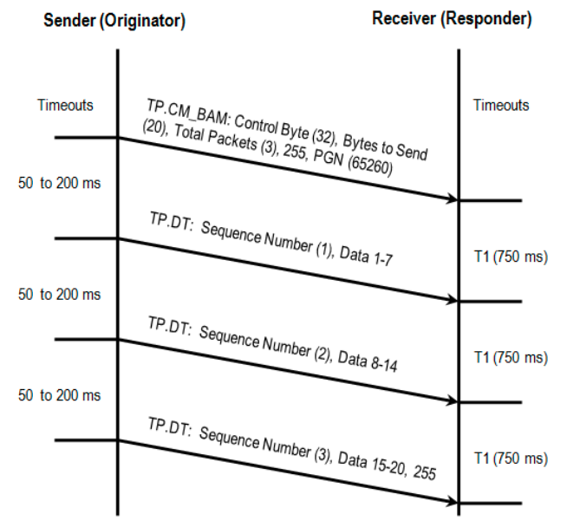Figure 3: Broadcast Announce Message(BAM)
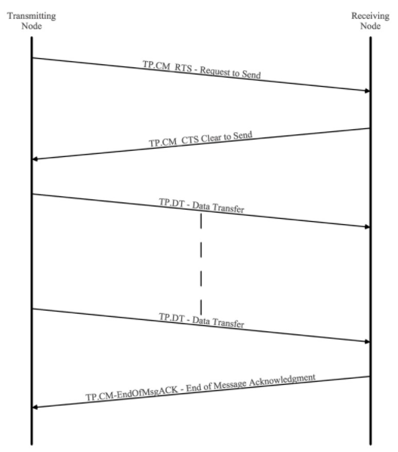Figure 4: Request To Send(RTS), Clear To Send(CTS) and EndOfMsgACK

Transport Protocol Data Transfer
This sending packages to the receiver ECU. Transport Protocol Connection Management must be sent first. Else the receiver won’t know how many packages and total data and PGN number we the transmitter is sending.
Message ID | 1C EB "DA" "SA"
PGN | 0x00EB00 (60160)
Peer to Peer/Broadcast | Peer to Peer
Message length | 8 bytes
Multipacket | No
Byte 1 | Sequence number
Byte 2 | Data 1
Byte 3 | Data 2
Byte 4 | Data 3
Byte 5 | Data 4
Byte 6 | Data 5
Byte 7 | Data 6
Byte 8 | Data 7

Field | Min value | Max value | Explanation | Enum
Sequence number | 0x0 | 0xE0 | This is the order/index of the data transfer packages
Data 1 to Data 7 | 0x0 | 0xFF | Your data bytes

Address Claimed
This describes the NAME about the ECU, and also the other ECU get to know its SA.

Message ID | 18 EE FF "SA"
PGN | 0x00EE00 (60928)
Peer to Peer/Broadcast | Broadcast
Message length | 8 bytes
Multipacket | No
Repetition rate | Sent at power on, after a “Request” for “Address Claim” and after a “Commanded Address”
Byte 1 | Identity number LSB
Byte 2 | Identity number
Byte 3 | Manufacturer code LSB [8..6], Identity number MSB [5..1]
Byte 4 | Manufacturer code MSB
Byte 5 | Function instance [8..4], ECU Instance [3..1]
Byte 6 | Function
Byte 7 | Vehicle system [8..2], 0x1 (Reserved) [1]
Byte 8 | Arbitrary address capable [8], Industry group [7..5], Vehicle system instance [4..1]

Notice that [X..Y] describes the bit index in the byte. It more likely looks like this.
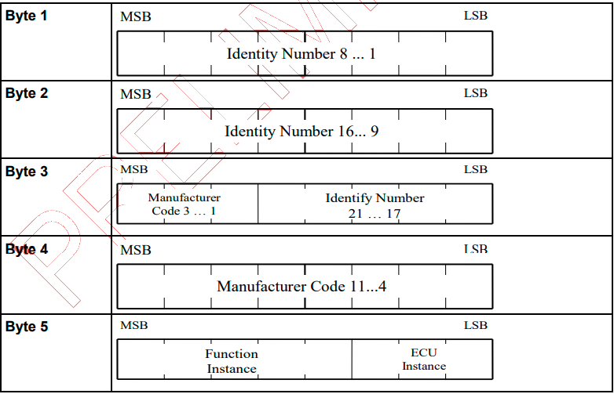Figure 5: How to interpret
Field | Min value | Max value | Explanation | Enum
Identity number | 0x0 | 0x1FFFFF | ECU identity number
Manufacturer code | 0x0 | 0x7FF | ECU manufacturer code
Function instance | 0x0 | 0x1F | ECU function area
ECU instance | 0x0 | 0x7 | ECU function area
Function | 0x0 | 0xFF | ECU functionality | Enum_NAME.h
Vehicle system | 0x0 | 0x7F | Where in the vehicle system the ECU is located
Arbitrary address capable | 0x0 | 0x1 | If the ECU have right to change address if the address conflicts with another ECU | Enum_NAME.h
Industry group | 0x0 | 0x7 | Where in the industry the ECU is located | Enum_NAME.h
Vehicle system instance | 0x0 | 0xF | The vehicle system code

Address not claimed
When an ECU cannot claim their address, the other ECU will receive this message. The user don’t know which ECU cannot claim their address. The user can only see the amount of how many ECU could not claim their address and the NAME of the ECU who could not claim its address. To find which name, just look at the ECU address 0xFE. See the uint8_t variable number_of_cannot_claim_address inside the struct J1939.

Message ID | 18 EE FF FE
PGN | 0x00EE00 (60928)
Peer to Peer/Broadcast | Broadcast
Message length | 8 bytes
Multipacket | No
Repetition rate | Sent if ECU address conflicts with other addresses
Byte 1 | Identity number LSB
Byte 2 | Identity number
Byte 3 | Manufacturer code LSB [8..6], Identity number MSB [5..1]
Byte 4 | Manufacturer code MSB
Byte 5 | Function instance [8..4], ECU Instance [3..1]
Byte 6 | Function
Byte 7 | Vehicle system [8..2], 0x1 (Reserved) [1]
Byte 8 | Arbitrary address capable [8], Industry group [7..5], Vehicle system instance [4..1]

Commanded Address
This command is used when the user want to change the NAME + SA at an ECU. Notice that this PGN don’t have an ID because Commanded Address DATA is 9 bytes and therefore using transport protocol data transfer.
PGN | 0x00FED8 (65240)
Peer to Peer/Broadcast | Broadcast
Message length | 8 bytes
Multipacket | Yes. Use Transport Protocol Connection Management → Transport Protocol Data Transfer
Byte 1 | Identity number LSB
Byte 2 | Identity number
Byte 3 | Manufacturer code LSB [8..6], Identity number MSB [5..1]
Byte 4 | Manufacturer code MSB
Byte 5 | Function instance [8..4], ECU Instance [3..1]
Byte 6 | Function
Byte 7 | Vehicle system [8..2], 0x1 (Reserved) [1]
Byte 8 | Arbitrary address capable [8], Industry group [7..5], Vehicle system instance [4..1]
Byte 9 | New ECU address

Field | Min value | Max value | Explanation | Enum
New ECU address | 0x0 | 0xFD | New address of the ECU

Delete Address
This is not a SAE J1939 standard. It’s made up by me. The reason is that I cannot find an ECU that deletes an address. Because Open SAE J1939 library remembers all the ECU addresses of other ECU addresses. Just to have the ability to count how many are connected and how many are not connected. Good to know. I have looked up the PGN at ISOBUS and I haven’t found any PGN with the number 2. So I guess it’s free for me to use then.
Message ID | 00 02 "DA" "SA"
PGN | 0x000002 (2)
Peer to Peer/Broadcast | Peer to Peer or Broadcast with DA = 0xFF (Used if the user want all ECU to delete a specific address for example after Commanded Address)
Message length | 8 bytes
Multipacket | No
Byte 1 | Old ECU address
Byte 2 | 0xFF (Reserved)
Byte 3 | 0xFF (Reserved)
Byte 4 | 0xFF (Reserved)
Byte 5 | 0xFF (Reserved)
Byte 6 | 0xFF (Reserved)
Byte 7 | 0xFF (Reserved)
Byte 8 | 0xFF (Reserved)

Field | Min value | Max value | Explanation | Enum
Old ECU address | 0x0 | 0xFD | This ECU address is going to disapear from ECU_address[255] array in J1939 struct

DM1
Diagnostics of error and location of an ECU. Notice that this message ID don’t have a destination address because it’s a broadcast message to all ECU.
Message ID | 18 FE CA "SA"
PGN | 0x00FECA (65226)
Peer to Peer/Broadcast | Broadcast
Message length | 8 bytes
Multipacket | No: Normal transfer  Yes: Use Transport Protocol Connection Management → Transport Protocol Data Transfer
Repetition rate | - On request from other ECU  - When an error becomes active
Byte 1 | SAE Lamp status malfunction indicator [8..7],  SAE Lamp status red stop [6..5],  SAE Lamp status amber warning [4..3],  SAE lamp status protect lamp [2..1]
Byte 2 | SAE Flash lamp malfunction indicator [8..7],  SAE Flash lamp red stop [6..5],  SAE Flash lamp amber warning [4..3],  SAE Flash lamp protect lamp [2..1]
Byte 3 | SPN LSB
Byte 4 | SPN
Byte 5 | SPN MSB [8..6], FMI [5..1]
Byte 6 | SPN conversion method [8], Occurrence count[7..1]
Byte 7 | 0xFF (Reserved)
Byte 8 | 0xFF (Reserved)

Field | Min value | Max value | Explanation | Enum
SAE Lamp status malfunction indicator | 0x0 | 0x1 | SAE lamp indicates fault
SAE Lamp status red stop | 0x0 | 0x1 | SAE lamp becomes red
SAE Lamp status amber warning | 0x0 | 0x1 | SAE lamp warns with amber light
SAE lamp status protect lamp | 0x0 | 0x1 | SAE lamp lights up the protection light
SAE Flash lamp malfunction indicator | 0x0 | 0x1 | SAE flash lamp indicates fault
SAE Flash Lamp red stop | 0x0 | 0x1 | SAE flash lamp becomes red
SAE Flash Lamp amber warning | 0x0 | 0x1 | SAE flash lamp warns with amber light
SAE Flash lamp protect lamp | 0x0 | 0x1 | SAE flash lamp lights up the protection light
SPN | 0x0 | 0x7FFFFF | Suspect Parameter Number – Location of the fault | Enum_DM1_DM2.h
FMI | 0x0 | 0x1F | Failure Mode Identifier – What cause the fault | Enum_DM1_DM2.h
SPN Conversion method | 0x0 | 0x1 | 1 = Diagnostics Trouble Code are aligned using a newer conversion method. 0 = One of the three Diagnostics Trouble Code conversion methods is used and ECU manufacture shall know which of the three methods is used
Occurence count | 0x0 | 0x7E | Count how often the DM1 error message becomes active

DM2
DM2 is the previous active DM1 messages. Them shares the same SPN and FMI codes.
Message ID | 18 FE CB "SA"
PGN | 0x00FECB (65227)
Peer to Peer/Broadcast | Broadcast
Message length | 8 bytes
Multipacket | No: Normal transfer  Yes: Use Transport Protocol Connection Management → Transport Protocol Data Transfer
Repetition rate | - On request from other ECU  - On request for DM3
Byte 1 | SAE Lamp status malfunction indicator [8..7],  SAE Lamp status red stop [6..5],  SAE Lamp status amber warning [4..3],  SAE lamp status protect lamp [2..1]
Byte 2 | SAE Flash lamp malfunction indicator [8..7],  SAE Flash lamp red stop [6..5],  SAE Flash lamp amber warning [4..3],  SAE Flash lamp protect lamp [2..1]
Byte 3 | SPN LSB
Byte 4 | SPN
Byte 5 | SPN MSB [8..6], FMI [5..1]
Byte 6 | SPN conversion method [8], Occurrence count[7..1]
Byte 7 | 0xFF (Reserved)
Byte 8 | 0xFF (Reserved)

DM3
DM3 is a request to clear DM2 messages. Use the request function above. After this is done, DM2 will be sent to all ECU via broadcast.
PGN | 0x00FECC (65228)

DM11 – Not supported
DM11 is a request for clearing DM1 messages. The reason why I don’t have implement it, is because in my opinion, it’s just an administrative burden that other ECU need to clear the DM1 error codes. I want the ECU it self to clear their own DM1 codes. The same way it activate the error codes by it self.

Proprietary A
Send out the Proprietary A of the ECU. Use this if you have data that are going to be synced or send out in a fixed repeated time interval.
Message ID | 14 EF 23 "SA"
PGN | 0x00EF00 (61184)
Peer to Peer/Broadcast | Broadcast
Message length | 8 bytes
Multipacket | No: Normal transfer  Yes: Use Transport Protocol Connection Management → Transport Protocol Data Transfer
Repetition rate | On request from other ECU
Byte 1-N | Manufacturer specific data

Field | Min value | Max value | Explanation | Enum
Manufacturer specific data 1 to N | 0x0 | 0xFF | Each data is one byte

Proprietary B PGNs
Send out the Proprietary B of the ECU. You can set up a number of arbitrary proprietary PGNs in the range reserved for the manufacturer by the standard.
Messages ID (range) | 00 FF 00 "SA" – 00 FF FF "SA"  01 FF 00 “SA” – 01 FF FF “SA” → Out of the standard, but supported
PGN (range) | 0x00FF00 (65280) – 0x00FFFF (65535)  0x01FF00 (130816) – 0x01FFFF (131071)
Peer to Peer/Broadcast | Peer to Peer or Broadcast with DA = 0xFF
Message length | Up to 1785 bytes
Multipacket | No: Normal transfer  Yes: Use Transport Protocol Connection Management → Transport Protocol Data Transfer
Repetition rate | On request from other ECU or periodic
Byte 1-N | Manufacturer specific data

Field | Min value | Max value | Explanation | Enum
Manufacturer specific data 1 to N | 0x0 | 0xFF | Each data is one byte

Software identification
Send out the software ID of the ECU. Notice that DA here in the message ID is not destination address. It’s the hex value 0xDA.
Message ID | 18 FE DA "SA"
PGN | 0x00FEDA (65242)
Peer to Peer/Broadcast | Broadcast
Message length | 8 bytes
Multipacket | No: Normal transfer  Yes: Use Transport Protocol Connection Management → Transport Protocol Data Transfer
Repetition rate | On request from other ECU
Byte 1 | Number of fields
Byte 2-N | Identification

Field | Min value | Max value | Explanation | Enum
Number of fields | 0x0 | 0x1E | How many fields we are going to transfer
Identification 1 to N | 0x0 | 0xFF | Each identification is one byte e.g ASCII

ECU identification
Send out ECU identification to the ECU.
Message ID | 18 FD C5 "SA"
PGN | 0x00FDC5 (64965)
Peer to Peer/Broadcast | Broadcast
Message length | 8 bytes
Multipacket | No: Normal transfer  Yes: Use Transport Protocol Connection Management → Transport Protocol Data Transfer
Repetition rate | On request from other ECU
Byte 1 | ECU part number
Byte 2 | ECU serial number
Byte 3 | ECU location
Byte 4 | ECU type
Byte 5 | 0xFF (Reserved)
Byte 6 | 0xFF (Reserved)
Byte 7 | 0xFF (Reserved)
Byte 8 | 0xFF (Reserved)

Notice that there are a field called length_of_each_field in ECU_identification inside the J1939 struct. If length_of_each_field = 1, then this message is going to be transfer in a normal way, else multipacket.
Field | Min value | Max value | Explanation | Enum
ECU part number | 0x0 | 0xFF | The part number in ASCII format
ECU serial number | 0x0 | 0xFF | The serial number in ASCII format
ECU location | 0x0 | 0xFF | The location in ASCII format
ECU type | 0x0 | 0xFF | The type in ASCII format

Component identification
Send out component identification to the ECU.
Message ID | 18 FE EB "SA"
PGN | 0x00FEEB (65259)
Peer to Peer/Broadcast | Broadcast
Message length | 8 bytes
Multipacket | No: Normal transfer  Yes: Use Transport Protocol Connection Management → Transport Protocol Data Transfer
Repetition rate | On request from other ECU
Byte 1 | Component product date
Byte 2 | Component model name
Byte 3 | Component serial number
Byte 4 | Component unit name
Byte 5 | 0xFF (Reserved)
Byte 6 | 0xFF (Reserved)
Byte 7 | 0xFF (Reserved)
Byte 8 | 0xFF (Reserved)

Notice that there are a field called length_of_each_field in Component_identification inside the J1939 struct. If length_of_each_field = 1, then this message is going to be transfer in a normal way, else multipacket.
Field | Min value | Max value | Explanation | Enum
Component product date | 0x0 | 0xFF | The product date in ASCII format
Component model name | 0x0 | 0xFF | The model name in ASCII format
Component serial number | 0x0 | 0xFF | The serial number in ASCII format
Component unit name | 0x0 | 0xFF | The unit name in ASCII format

VIN request
Request the VIN to an ECU. It’s a standard, always broadcast (DA = 0xFF) J1939 request with the requested PGN = 0x00FEEC (65260), see Request.

VIN response
Send out the VIN of the ECU. It’s a standard, always broadcast (DA = 0xFF) J1939 multiframe response. It uses a BAM, followed by three Data Transfer frames containing the 17 characters of the VIN. See BAM and Data Transfer. The last four Bytes of the last Data Transfer frame will always be 0xFF as it’s padding.

DM14 & DM15 and DM16
DM14 is a memory request. DM15 is a memory response for the DM14 memory request and if DM15 response was proceeded, then DM16 data transfer is called next.
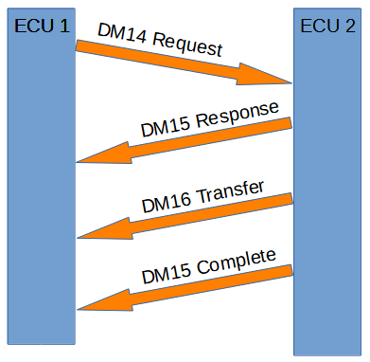Figure 5: DM14, DM15 and DM16
DM14 memory request:
Message ID | 18 D9 "DA" "SA"
PGN | 0x00D900 (55552)
Peer to Peer/Broadcast | Peer to Peer
Message length | 8 bytes
Multipacket | No
Byte 1 | Number of requested bytes LSB
Byte 2 | Number of requested bytes MSB [8..6], Pointer type [7], Command [6..3], 0x1 (Reserved) [1]
Byte 3 | Pointer LSB
Byte 4 | Pointer
Byte 5 | Pointer MSB
Byte 6 | Pointer extension
Byte 7 | Key LSB
Byte 8 | Key MSB

Field | Min value | Max value | Explanation | Enum
Number of requested bytes | 0x0 | 0x7FF | The question of how many bytes the ECU want to have
Pointer type | 0x0 | 0x1 | 0 if Pointer and Pointer extension are together one addresses. 1 if pointer is an address and Pointer extension is a way to describe a function code | Enum_DM14_DM15.h
Command | 0x0 | 0x7 | The command what to do | Enum_DM14_DM15.h
Pointer | 0x0 | 0xFFFFFF | The memory address
Pointer extension | 0x0 | 0xFF | Extra memory address, or it can be a function code | Enum_DM14_DM15.h
Key | 0x0 | 0xFFFF | Password or no password at all | Enum_DM14_DM15.h

DM15 memory response of the DM14 memory request:

Message ID | 18 D8 "DA" "SA"
PGN | 0x00D800 (55296)
Peer to Peer/Broadcast | Peer to Peer
Message length | 8 bytes
Multipacket | No
Repetition rate | On request from other ECU
Byte 1 | Number of allowed bytes LSB
Byte 2 | Number of allowed bytes MSB [8..6], 0x1 (Reserved) [7], Status [6..3], 0x1 (Reserved) [1]
Byte 3 | EDC parameter LSB
Byte 4 | EDC parameter
Byte 5 | EDC parameter MSB
Byte 6 | EDCP extension
Byte 7 | Seed LSB
Byte 8 | Seed MSB

Field | Min value | Max value | Explanation | Enum
Number of allowed bytes | 0x0 | 0x7FF | The question of how many bytes the ECU is going to have
Status | 0x0 | 0x7 | The response status of the request | Enum_DM14_DM15.h
EDC parameter | 0x0 | 0xFFFFFF | This is an explanation of the status response | Enum_DM14_DM15.h
EDCP extension | 0x0 | 0xFF | This is an explanation of the EDC parameter | Enum_DM14_DM15.h
Seed | 0x0 | 0xFFFF | Status of the key request | Enum_DM14_DM15.h

DM16 is binary data transfer:

Message ID | 18 D7 "DA" "SA"
PGN | 0x00D700 (55040)
Peer to Peer/Broadcast | Peer to Peer
Message length | 8 bytes
Multipacket | No: Normal transfer  Yes: Use Transport Protocol Connection Management → Transport Protocol Data Transfer
Byte 1 | Number of occurrences
Byte 2-256 | Raw binary data 1-255

Field | Min value | Max value | Explanation | Enum
Number of occurrences | 0x0 | 0xFF | How many raw binary data we have
Raw binary data 1-255 | 0x0 | 0xFF | Data to transfer

ISO 11783 Protocol

ISO 11783-7 Application Layer
This ISO standard is for agriculture, tractors and machinery.

Auxiliary Valve Command
Auxiliary valve command is a command from an ECU to broadcast to all other ECU. All it does it to tell other ECU which valve they are going to use and how they are going to use it. Maximum 16 valve numbers can be used, from 0 to 15 according to ISO 11783-7 standard.
Message ID | 0C FE (30+valve number) "SA"
PGN | 0x00FE(30+valve number) (65072+valve number)
Peer to Peer/Broadcast | Broadcast
Message length | 8 bytes
Multipacket | No
Byte 1 | Standard flow
Byte 2 | 0xFF (Reserved)
Byte 3 | Fail safe mode [8..7], 0x3 (Reserved) [6..5], Valve state [4..1]
Byte 4 | 0xFF (Reserved)
Byte 5 | 0xFF (Reserved)
Byte 6 | 0xFF (Reserved)
Byte 7 | 0xFF (Reserved)
Byte 8 | 0xFF (Reserved)

Field | Min value | Max value | Explanation | Enum
Standard flow | 0x0 | 0xFF | In practice, this is the position of the valve main spool
Fail safe mode | 0x0 | 0x1 | 1 = Spool go to neutral  0 = No fail safe mode | ISO_11783_Enum_Auxiliary_And_General_Purpose_Valves.h
Valve state | 0x0 | 0xF | What way the valve should act | ISO_11783_Enum_Auxiliary_And_General_Purpose_Valves.h

General Purpose Valve Command
The difference between Auxiliary Valve Command and General Purpose Valve Command is that Auxiliary Valve Command can hold 16 valves meanwhile General Purpose Valve Command can hold 1 valve.
Message ID | 0C C4 "DA" "SA"
PGN | 0x00C400 (50176)
Peer to Peer/Broadcast | Peer to Peer
Message length | 8 bytes
Multipacket | No
Byte 1 | Standard flow
Byte 2 | 0xFF (Reserved)
Byte 3 | Fail safe mode [8..7], 0x3 (Reserved) [6..5], Valve state [4..1]
Byte 4 | Extended flow LSB
Byte 5 | Extended flow MSB
Byte 6 | 0xFF (Reserved)
Byte 7 | 0xFF (Reserved)
Byte 8 | 0xFF (Reserved)

Field | Min value | Max value | Explanation | Enum
Standard flow | 0x0 | 0xFF | In practice, this is the position of the valve main spool
Fail safe mode | 0x0 | 0x1 | 1 = Spool go to neutral  0 = No fail safe mode | ISO_11783_Enum_Auxiliary_And_General_Purpose_Valves.h
Valve state | 0x0 | 0xF | What way the valve should act | ISO_11783_Enum_Auxiliary_And_General_Purpose_Valves.h
Extended flow | 0x0 | 0xFFFF | In practice, this is the position of the valve main spool in higher precision

Auxiliary Valve Estimated Flow
Broadcast estimated flow from an auxiliary valve. Total 16 valves can be used, from 0 to 15.
Message ID | 0C FE (10+valve number) "SA"
PGN | 0x00FE(10+valve number) (65040+valve number)
Peer to Peer/Broadcast | Broadcast
Message length | 8 bytes
Multipacket | No
Repetition rate | On request from other ECU
Byte 1 | Extend estimated flow standard
Byte 2 | Retract estimated flow standard
Byte 3 | Fail safe mode [8..7], 0x3 (Reserved) [6..5], Valve state [4..1]
Byte 4 | Limit [8..6], 0x1F (Reserved)
Byte 5 | 0xFF (Reserved)
Byte 6 | 0xFF (Reserved)
Byte 7 | 0xFF (Reserved)
Byte 8 | 0xFF (Reserved)

Field | Min value | Max value | Explanation | Enum
Extend estimated flow standard | 0x0 | 0xFF | In practice, this is the flow of the valve main spool
Retract estimated flow standard | 0x0 | 0xFF | In practice, this is the negative flow of the valve main spool
Fail safe mode | 0x0 | 0x1 | 1 = Spool go to neutral  0 = No fail safe mode | ISO_11783_Enum_Auxiliary_And_General_Purpose_Valves.h
Valve state | 0x0 | 0xF | What way the valve should act | ISO_11783_Enum_Auxiliary_And_General_Purpose_Valves.h
Limit | 0x0 | 0x7 | Limit code of the valve | ISO_11783_Enum_Auxiliary_And_General_Purpose_Valves.h

General Purpose Valve Estimated Flow
Broadcast estimated flow from a general purpose valve.
Message ID | 0C C6 "DA" "SA"
PGN | 0x00C600 (50688)
Peer to Peer/Broadcast | Peer to Peer
Message length | 8 bytes
Multipacket | No
Repetition rate | On request from other ECU
Byte 1 | Extend estimated flow standard
Byte 2 | Retract estimated flow standard
Byte 3 | Fail safe mode [8..7], 0x3 (Reserved) [6..5], Valve state [4..1]
Byte 4 | Limit [8..6], 0x1F (Reserved)
Byte 5 | Extend estimated flow extended LSB
Byte 6 | Extend estimated flow extended MSB
Byte 7 | Retract estimated flow extended LSB
Byte 8 | Retract estimated flow extended MSB

Field | Min value | Max value | Explanation | Enum
Extend estimated flow standard | 0x0 | 0xFF | In practice, this is the flow of the valve main spool
Retract estimated flow standard | 0x0 | 0xFF | In practice, this is the negative flow of the valve main spool
Fail safe mode | 0x0 | 0x1 | 1 = Spool go to neutral  0 = No fail safe mode | ISO_11783_Enum_Auxiliary_And_General_Purpose_Valves.h
Valve state | 0x0 | 0xF | What way the valve should act | ISO_11783_Enum_Auxiliary_And_General_Purpose_Valves.h
Limit | 0x0 | 0x7 | Limit code of the valve | ISO_11783_Enum_Auxiliary_And_General_Purpose_Valves.h
Extend estimated flow extended | 0x0 | 0xFFFF | In practice, this is the high precision flow of the valve main spool
Retract estimated flow extended | 0x0 | 0xFFFF | In practice, this is the negative high precision flow of the valve main spool

Auxiliary Valve Measured Position
Broadcast measured position from an auxiliary valve. Total 16 valves can be used, from 0 to 15.
Message ID | 0C FF (20+valve number) "SA"
PGN | 0x00FF(20+valve number) (65312+valve number)
Peer to Peer/Broadcast | Broadcast
Message length | 8 bytes
Multipacket | No
Repetition rate | On request from other ECU
Byte 1 | Measured position percent LSB
Byte 2 | Measured position percent MSB
Byte 3 | 0xF (Reserved) [8..5], Valve state[4..1]
Byte 4 | Measured position micrometer LSB
Byte 5 | Measured position micrometer MSB
Byte 6 | 0xFF (Reserved)
Byte 7 | 0xFF (Reserved)
Byte 8 | 0xFF (Reserved)

Field | Min value | Max value | Explanation | Enum
Measured position percent | 0x0 | 0xFFFF | In practice, this is the position in percent of main spool
Valve state | 0x0 | 0xF | What way the valve should act | ISO_11783_Enum_Auxiliary_And_General_Purpose_Valves.h
Measured position micrometer | 0x0 | 0xFFFF | In practice, this is the position in micrometer of main spool | ISO_11783_Enum_Auxiliary_And_General_Purpose_Valves.h

Revision
- 2023-12-25: Add Proprietary A functionality
- 2024-04-27: Add CTS, RTS, Connection Abort, Acknowledgement for TP.CM
- 2024-11-03: Add Proprietary B functionality
- 2026-09-09: Add VIN request/response

